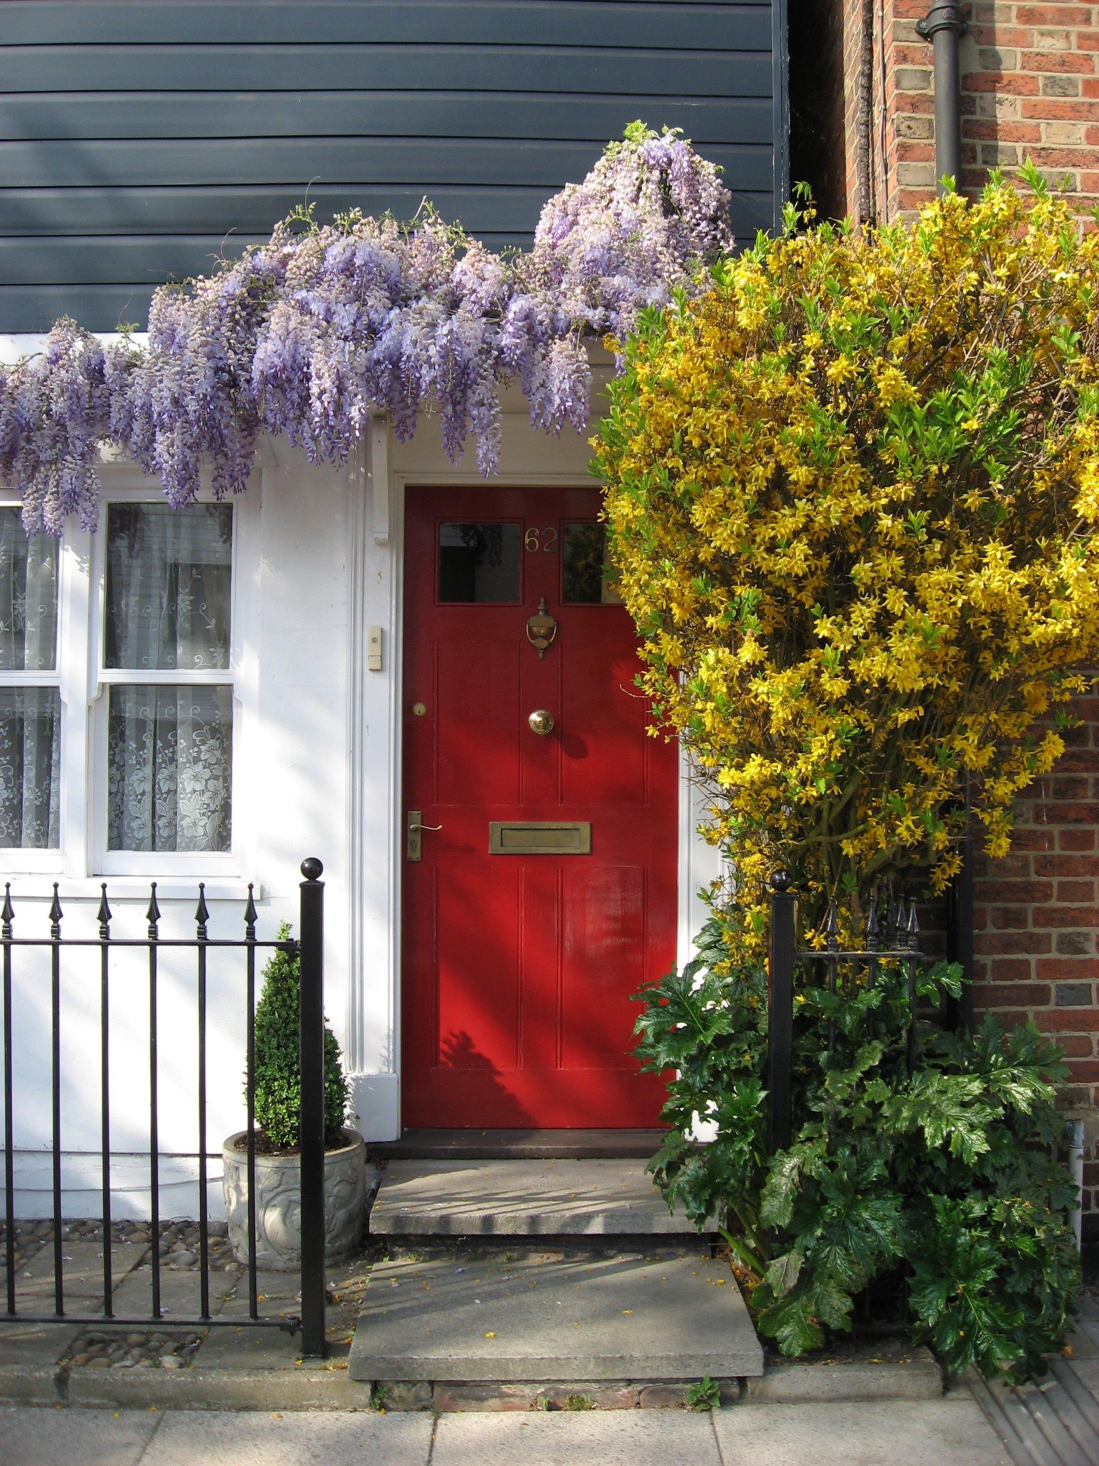

Jesus
is the head
of this house
Copyright © GospelRiver.com
Photo sxc.hu #771455

