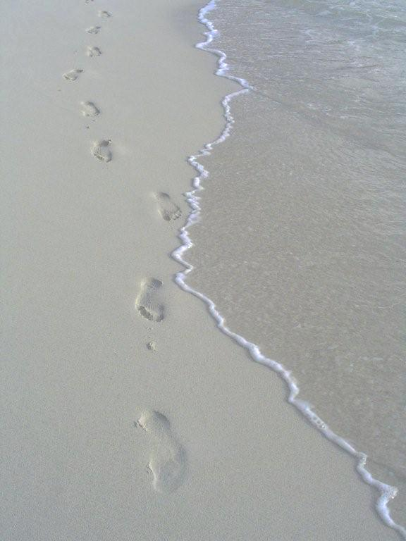
The path that led into the light
I could not find! In that dark night
God took my hand.
He led me that I might not stray,
And brought me by a new, safe way
I had not known.
By waters still, through pastures green
I followed Him--the path was clean
Of briar and stone.
The heavy darkness lost its strength,
My waiting eyes beheld at length
The streaking dawn.
On, safely on, through sunrise glow
I walked, my hand in His, and lo,
The night had gone.

--Annie Porter Johnson
© 2011 GospelRiver.com

The path that led into the light
I could not find! In that dark night
God took my hand.
He led me that I might not stray,
And brought me by a new, safe way
I had not known.
By waters still, through pastures green
I followed Him--the path was clean
Of briar and stone.
The heavy darkness lost its strength,
My waiting eyes beheld at length
The streaking dawn.
On, safely on, through sunrise glow
I walked, my hand in His, and lo,
The night had gone.

--Annie Porter Johnson
© 2011 GospelRiver.com

The path that led into the light
I could not find! In that dark night
God took my hand.
He led me that I might not stray,
And brought me by a new, safe way
I had not known.
By waters still, through pastures green
I followed Him--the path was clean
Of briar and stone.
The heavy darkness lost its strength,
My waiting eyes beheld at length
The streaking dawn.
On, safely on, through sunrise glow
I walked, my hand in His, and lo,
The night had gone.

--Annie Porter Johnson
© 2011 GospelRiver.com

The path that led into the light
I could not find! In that dark night
God took my hand.
He led me that I might not stray,
And brought me by a new, safe way
I had not known.
By waters still, through pastures green
I followed Him--the path was clean
Of briar and stone.
The heavy darkness lost its strength,
My waiting eyes beheld at length
The streaking dawn.
On, safely on, through sunrise glow
I walked, my hand in His, and lo,
The night had gone.

--Annie Porter Johnson
© 2011 GospelRiver.com

The path that led into the light
I could not find! In that dark night
God took my hand.
He led me that I might not stray,
And brought me by a new, safe way
I had not known.
By waters still, through pastures green
I followed Him--the path was clean
Of briar and stone.
The heavy darkness lost its strength,
My waiting eyes beheld at length
The streaking dawn.
On, safely on, through sunrise glow
I walked, my hand in His, and lo,
The night had gone.

--Annie Porter Johnson
© 2011 GospelRiver.com

