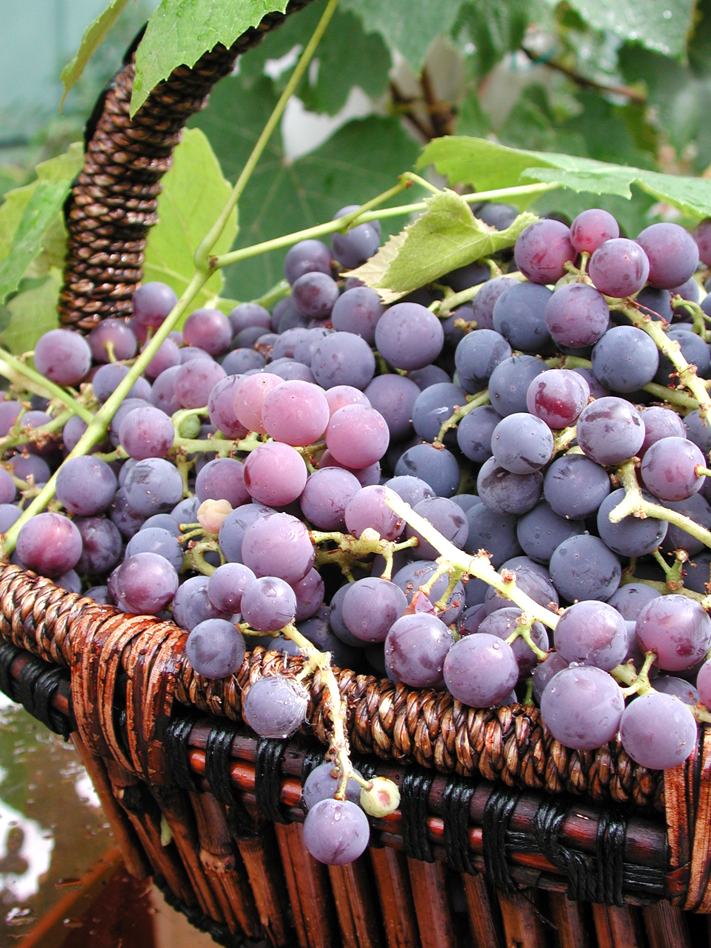
But the fruit of the Spirit is
love,
joy,
peace, patience, kindness, goodness, faithfulness, gentleness and
self-control.

Galatians 5:22-23
NIV
of the
Copyright © GospelRiver.com
Spirit
Fruit

