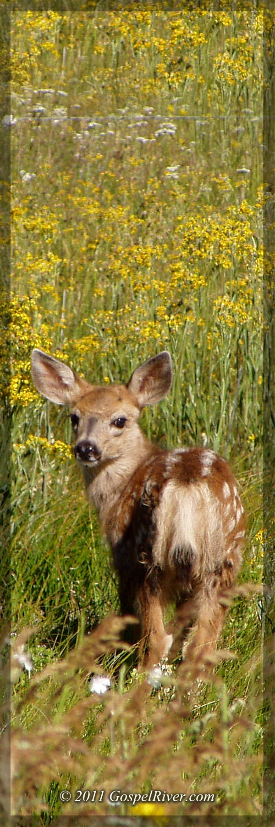
Look unto Me, and be ye saved…
for I
am God

Isaiah 45:22

