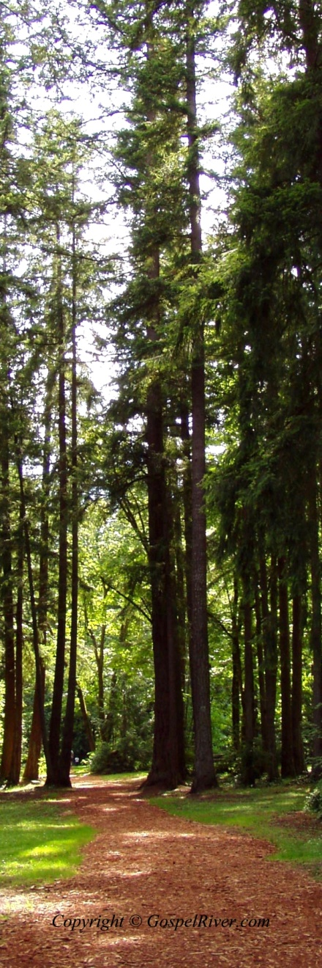
He raises up the poor out of the dust and lifts up the needy from the ash heap, to make them sit with nobles and inherit the throne of glory. For the pillars of the earth are the Lord's, and He has set the world upon them.
1 Samuel 2:8
Amplified

