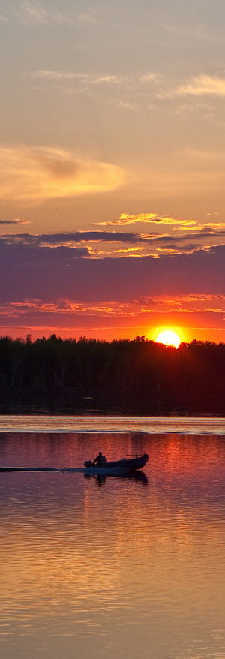
© 2011 GospelRiver.com
Photo: © NorthernImages.com
Behold, I will send for many fishers, saith the LORD, and they shall fish them; and after will I send for many hunters, and they shall hunt them from every mountain, and from every hill, and out of the holes of the rocks.

Jeremiah 16:16

