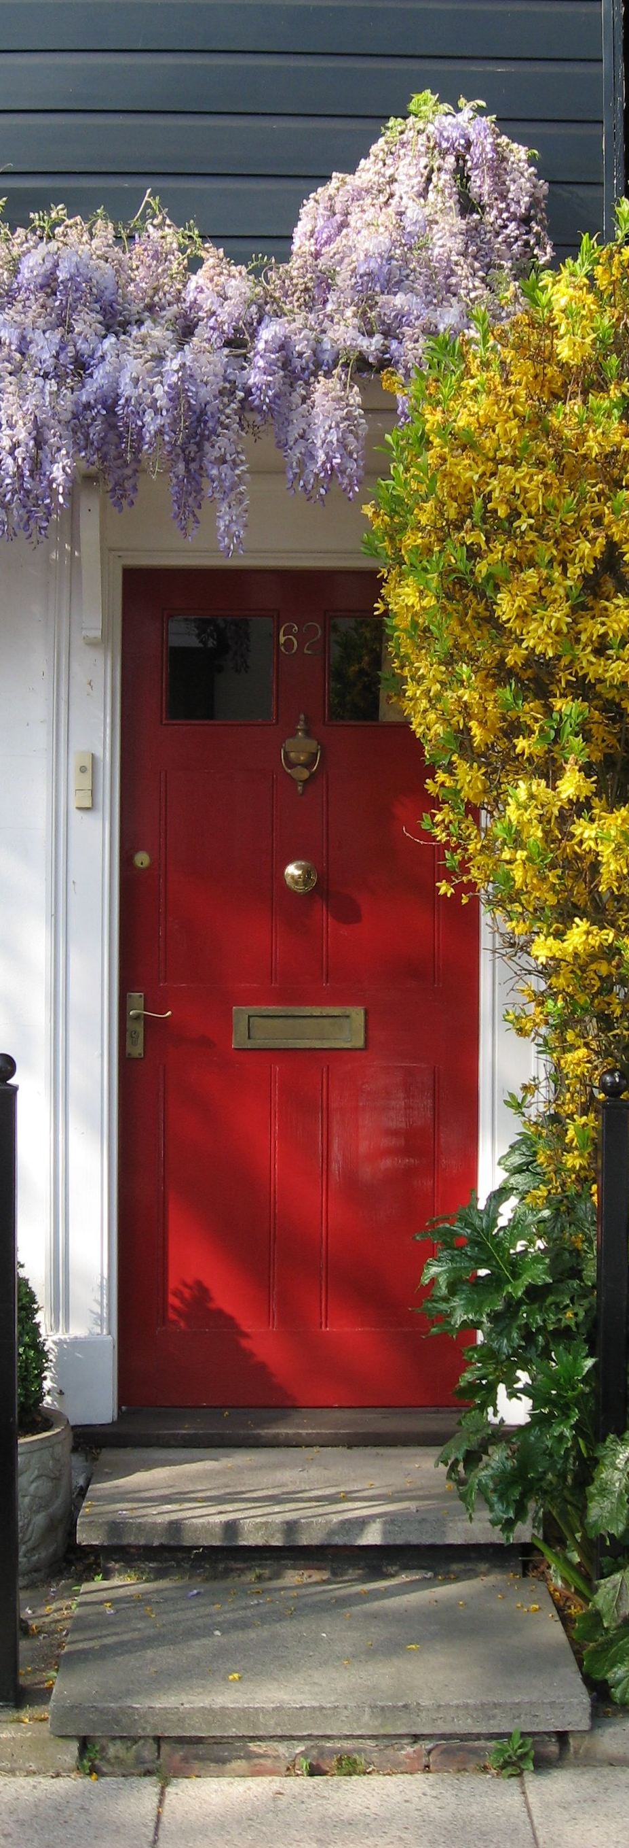
Be still
and know
that I
am God

Psalm 46:10
NIV 1984
© GospelRiver.com
Photo sxc.hu #771455

