 | Day | OT
 | 1 | Gen 1-2
 | 2 | Gen 3-4
 | 3 | Gen 5-6
 | 4 | Gen 7-8
 | 5 | Gen 9-10
 | 6 | Gen 11-12
 | 7 | Gen 13-14
 | 8 | Gen 16-17
 | 9 | Gen 18-19
 | 10 | Gen 20-21
 | 11 | Gen 22-23
 | 12 | Gen 24
 | 13 | Gen 25-26
 | 14 | Gen 27
 | 15 | Gen 28-29
 | 16 | Gen 30
 | 17 | Gen 31
 | 18 | Gen 32-33
 | 19 | Gen 34-35
 | 20 | Gen 36
 | 21 | Gen 37-38
 | 22 | Gen 39-40
 | 23 | Gen 41-42
 | 24 | Gen 43-44
 | 25 | Gen 45-46
 | 26 | Gen 47-48
 | 27 | Gen 49-50
 | 28 | Ex 1
 | 29 | Ex 2-3
 | 30 | Ex 4-5
 | 31 | Ex 6-7
 | Day | OT
 | 32 | Ex 8-9
 | 33 | Ex 10-11
 | 34 | Ex 12
 | 35 | Ex 13-14
 | 36 | Ex 15-16
 | 37 | Ex 17-19
 | 38 | Ex 20-21
 | 39 | Ex 22-23
 | 40 | Ex 24-25
 | 41 | Ex 26-27
 | 42 | Ex 28
 | 43 | Ex 29-30
 | 44 | Ex 31-32
 | 45 | Ex 33-34
 | 46 | Ex 35-36
 | 47 | Ex 37-38
 | 48 | Ex 39-40
 | 49 | Lev 1
 | 50 | Lev 2-4
 | 51 | Lev 5-6
 | 52 | Lev 7
 | 53 | Lev 8-9
 | 54 | Lev 10-11
 | 55 | Lev 12-13
 | 56 | Lev 14
 | 57 | Lev 15-16
 | 58 | Lev 17-18
 | 59 | Lev 19-20
 | Day | OT
 | 60 | Lev 21-22
 | 61 | Lev 23-24
 | 62 | Lev 25
 | 63 | Lev 26
 | 64 | Lev 27
 | 65 | Num 1
 | 66 | Num 2
 | 67 | Num 3
 | 68 | Num 4
 | 69 | Num 5-6
 | 70 | Num 7
 | 71 | Num 8-9
 | 72 | Num 10-11
 | 73 | Num 12-13
 | 74 | Num 14
 | 75 | Num 15
 | 76 | Num 16
 | 77 | Num 17-18
 | 78 | Num 19-20
 | 79 | Num 21-22
 | 80 | Num 23-24
 | 81 | Num 25-26
 | 82 | Num 27-28
 | 83 | Num 29-30
 | 84 | Num 31
 | 85 | Num 32
 | 86 | Num 33-34
 | 87 | Num 35-36
 | 88 | Deut 1
 | 89 | Deut 2-3
 | 90 | Deut 4
 | Day | OT
 | 91 | Deut 5-6
 | 92 | Deut 7-8
 | 93 | Duet 9-10
 | 94 | Deut 11-12
 | 95 | Deut 13-14
 | 96 | Deut 15-16
 | 97 | Deut 18-20
 | 98 | Deut 21-22
 | 99 | Deut 23-24
 | 100 | Deut 25-27
 | 101 | Deut 28
 | 102 | Deut 29-30
 | 103 | Duet 31-32
 | 104 | Deut 33-34
 | 105 | Josh 1
 | 106 | Josh 2-4
 | 107 | Josh 5-7
 | 108 | Josh 8-9
 | 109 | Josh 10-11
 | 110 | Josh 12-13
 | 111 | Josh 14-15
 | 112 | Josh 16-18
 | 113 | Josh 19-20
 | 114 | Josh 21-22
 | 115 | Josh 23-24
 | 116 | Judg 1
 | 117 | Judg 2-3
 | 118 | Judg 4-5
 | 119 | Judg 6-7
 | 120 | Judg 8
 | Day | OT
 | 121 | Judg 9
 | 122 | Judg 10-11
 | 123 | Judg 12-14
 | 124 | Judg 15-16
 | 125 | Judg 17-18
 | 126 | Judg 19-21
 | 127 | 1Sam 1-2
 | 128 | 1Sam 3-5
 | 129 | 1Sam 6-8
 | 130 | 1Sam 9-10
 | 131 | 1Sam 11-13
 | 132 | 1Sam 14
 | 133 | 1Sam 15-16
 | 134 | 1Sam 17
 | 135 | 1Sam 18-19
 | 136 | 1Sam 20-21
 | 137 | 1Sam 22-23
 | 138 | 1Sam 24-25
 | 139 | 1Sam 26-28
 | 140 | 1Sam 29-31
 | 141 | 2Sam 1-2
 | 142 | 2Sam 3-4
 | 143 | 2Sam 5-6
 | 144 | 2Sam 7-9
 | 145 | 2Sam 10-11
 | 146 | 2Sam 12-13
 | 147 | 2Sam 14-15
 | 148 | 2Sam 16-17
 | 149 | 2Sam 18-19
 | 150 | 2Sam 20-21
 | 151 | 2Sam 22

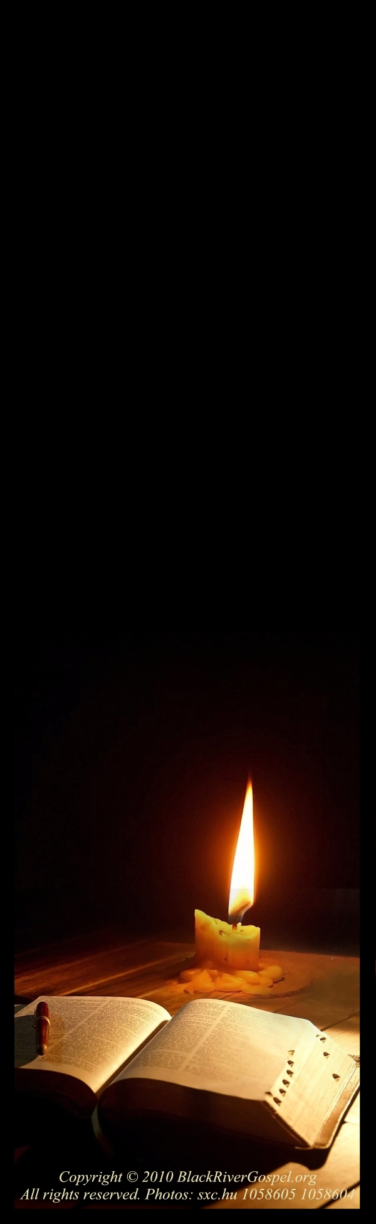
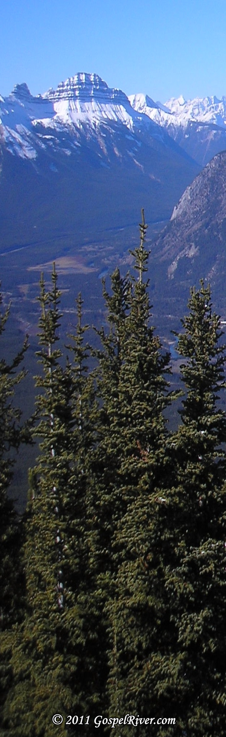

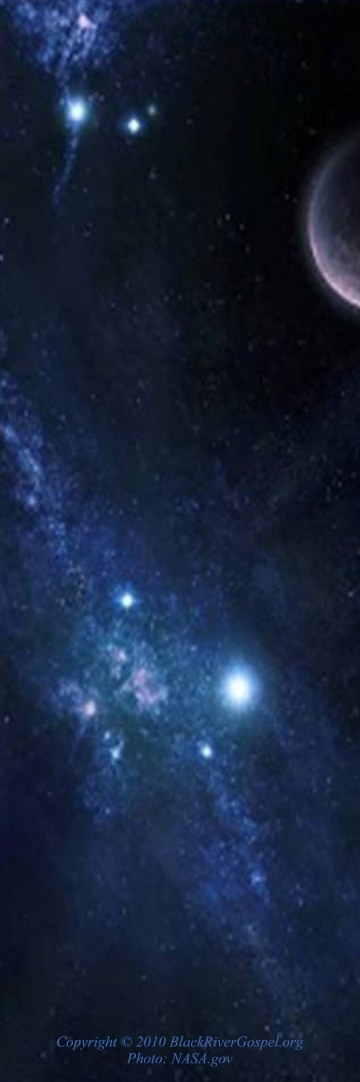
Reading Plan
Reading Plan
Reading Plan

Reading Plan
Reading Plan

 | Day | OT
 | 152 | 2Sam 23-24
 | 153 | 1Kings 1
 | 154 | 1Kings 2
 | 155 | 1Kings 3-4
 | 156 | 1Kings 5-6
 | 157 | 1Kings 7
 | 158 | 1Kings 8
 | 159 | 1Kings 9-10
 | 160 | 1Kings 11
 | 161 | 1Kings 12-13
 | 162 | 1Kings 14-15
 | 163 | 1Kings 16-17
 | 164 | 1Kings 18
 | 165 | 1Kings 19-20
 | 166 | 1Kings 21-22
 | 167 | 2Kings 1-2
 | 168 | 2Kings 3-4
 | 169 | 2Kings 5-6
 | 170 | 2Kings 7-8
 | 171 | 2Kings 9-10
 | 172 | 2Kings 11-13
 | 173 | 2Kings 14-15
 | 174 | 2Kings 16-17
 | 175 | 2Kings 18
 | 176 | 2Kings 19-20
 | 177 | 2Kings 21-22
 | 178 | 2Kings 23-24
 | 179 | 2Kings 25
 | 180 | 1Chron 1
 | 181 | 1Chron 2
 | Day | OT
 | 213 | Ezra 1-2
 | 214 | Ezra 3-4
 | 215 | Ezra 5-6
 | 216 | Ezra 7-8
 | 217 | Ezra 9-10
 | 218 | Neh 1-2
 | 219 | Neh 3-4
 | 220 | Neh 5-6
 | 221 | Neh 7
 | 222 | Neh 8-9
 | 223 | Neh 10
 | 224 | Neh 11
 | 225 | Neh 12-13
 | 226 | Job 1-2
 | 227 | Job 3-4
 | 228 | Job 5-6
 | 229 | Job 7-8
 | 230 | Job 9-10
 | 231 | Job 11-12
 | 232 | Job 13-14
 | 233 | Job 15-16
 | 234 | Job 17-19
 | 235 | Job 20-21
 | 236 | Job 22-23
 | 237 | Job 24-26
 | 238 | Job 27-28
 | 239 | Job 29-30
 | 240 | Job 31-32
 | 241 | Job 33-34
 | 242 | Job 35-36
 | 243 | Job 37-38
 | Day | OT
 | 244 | Job 39-40
 | 245 | Job 41-42
 | 246 | Ecc 1-2
 | 247 | Ecc 3-4
 | 248 | Ecc 5-6
 | 249 | Ecc 7-8
 | 250 | Ecc 9-10
 | 251 | Ecc 11-12
 | 252 | Isa 1
 | 253 | Isa 2-3
 | 254 | Isa 4-5
 | 255 | Isa 6-7
 | 256 | Isa 8-9
 | 257 | Isa 10-12
 | 258 | Isa 13-14
 | 259 | Isa 15-17
 | 260 | Isa 18-19
 | 261 | Isa 20-22
 | 262 | Isa 23-25
 | 263 | Isa 26-27
 | 264 | Isa 28-29
 | 265 | Isa 30-31
 | 266 | Isa 32-33
 | 267 | Isa 34-36
 | 268 | Isa 37-38
 | 269 | Isa 39-41
 | 270 | Isa 42-43
 | 271 | Isa 44-45
 | 272 | Isa 46-47
 | 273 | Isa 48-49
 | Day | OT
 | 274 | Isa 50-51
 | 275 | Isa 52-53
 | 276 | Isa 54-55
 | 277 | Isa 56-57
 | 278 | Isa 58-59
 | 279 | Isa 60-61
 | 280 | Isa 62-64
 | 281 | Isa 65-66
 | 282 | Jer 1
 | 283 | Jer 2-3
 | 284 | Jer 4-5
 | 285 | Jer 6-7
 | 286 | Jer 8-9
 | 287 | Jer 10-12
 | 288 | Jer 13-14
 | 289 | Jer 15-16
 | 290 | Jer 17-18
 | 291 | Jer 19-20
 | 292 | Jer 21-22
 | 293 | Jer 23-24
 | 294 | Jer 25-26
 | 295 | Jer 27-28
 | 296 | Jer 29-30
 | 297 | Jer 31-32
 | 298 | Jer 33-34
 | 299 | Jer 35-36
 | 300 | Jer 37-38
 | 301 | Jer 39-40
 | 302 | Jer 41-42
 | 303 | Jer 43-44
 | 304 | Jer 44-45





Reading Plan
Reading Plan
Reading Plan

Reading Plan
Reading Plan
 | Day | OT
 | 182 | 1Chron 3-4
 | 183 | 1Chron 5
 | 184 | 1Chron 6
 | 185 | 1Chron 7
 | 186 | 1Chron 8
 | 187 | 1Chron 9-10
 | 188 | 1Chron 11
 | 189 | 1Chron 12-13
 | 190 | 1Chron 14-15
 | 191 | 1Chron 16-17
 | 192 | 1Chron 18-19
 | 193 | 1Chron 20-21
 | 194 | 1Chron 22-23
 | 195 | 1Chron 24-25
 | 196 | 1Chron 26-27
 | 197 | 1Chron 28-29
 | 198 | 2Chron 1
 | 199 | 2Chron 2-4
 | 200 | 2Chron 5-6
 | 201 | 2Chron 7-9
 | 202 | 2Chron 10-12
 | 203 | 2Chron 13-15
 | 204 | 2Chron 16-18
 | 205 | 2Chron 19-20
 | 206 | 2Chron 21-23
 | 207 | 2Chron 24-25
 | 208 | 2Chron 26-28
 | 209 | 2Chron 29-30
 | 210 | 2Chron 31-32
 | 211 | 2Chron 33-34
 | 212 | 2Chron 35-36



Reading Plan
Reading Plan

 | Day | OT
 | 305 | Jer 46-47
 | 306 | Jer 48
 | 307 | Jer 49
 | 308 | Jer 50
 | 309 | Jer 51
 | 310 | Jer 52
 | 311 | Lam 1
 | 312 | Lam 2-3
 | 313 | Lam 4-5
 | 314 | Ezek 1-3
 | 315 | Ezek 4-5
 | 316 | Ezek 6-7
 | 317 | Ezek 8-9
 | 318 | Ezek 10-11
 | 319 | Ezek 12-13
 | 320 | Ezek 14-15
 | 321 | Ezek 16
 | 322 | Ezek 17-18
 | 323 | Ezek 19-20
 | 324 | Ezek 21-22
 | 325 | Ezek 23
 | 326 | Ezek 24-26
 | 327 | Ezek 27-28
 | 328 | Ezek 29-31
 | 329 | Ezek 32-33
 | 330 | Ezek 34-35
 | 331 | Ezek 36-37
 | 332 | Ezek 38-39
 | 333 | Ezek 40-41
 | 334 | Ezek 42-43
 | Day | OT
 | 335 | Ezek 44-45
 | 336 | Ezek 46-47
 | 337 | Ezek 48
 | 338 | Hos 1-2
 | 339 | Hos 3-5
 | 340 | Hos 6-9
 | 341 | Hos 10-12
 | 342 | Hos 13-14
 | 343 | Joel 1-3
 | 344 | Amos 1-2
 | 345 | Amos 3-5
 | 346 | Amos 6-7
 | 347 | Amos 8-9
 | 348 | Obad
 | 349 | Jonah 1-2
 | 350 | Jonah 3-4
 | 351 | Mic 1-3
 | 352 | Mic 4-5
 | 353 | Mic 6-7
 | 354 | Nah 1-3
 | 355 | Hab 1-3
 | 356 | Zeph 1-3
 | 357 | Hag 1-2
 | 358 | Zech 1-3
 | 359 | Zech 4-6
 | 360 | Zech 7-8
 | 361 | Zech 9-10
 | 362 | Zech 11-12
 | 363 | Zech 13-14
 | 364 | Mal 1-2
 | 365 | Mal 3-4

